**EXPERIMENT NO. 9**

**EXPERIMENT NO. 9**

**AIM**: To configure DNS server using cisco packet tracer

**REQUIREMENT**: cisco packet tracer **THEORY**:

Domain Name Server (DNS) is a client server application. It is used by users (human) in the Internet to access the domain names like gmail.com, yahoo.com, google.com etc. All these domains can be accessed using their IP addresses. But for human beings it is cumbersome to remember the numeric IP addresses for various sites. So the DNS servers are configured to map the domain names (like www.xyz.com) to their IP addresses. Thus whenever the users access any servers in the Internet, the IP addresses are provided for their mapped domain names by the DNS. In other words, DNS translates the domain names to IP addresses.

**PROCEDURE:**

Create a topology having at least one PC (you can take more than two), a router (as default gateway, optional), one or more servers. One of the server can be configured as web server, other as DHCP, another as DNS etc. (At least one server is required for configuring DNS), switch for connecting PCs in LAN)

1. Assign IP address on DNS server, start DNS services, create “A” record for its domain name.
2. Configure the router as default gateway. This will act as default gateway for all PCs, DNS and DHCP servers.
3. Configure DHCP server, define IP address pool.
4. Each PC will get IP address from DHCP server.
5. Configure each PC with DNS server IP server.
6. Using a web browser from each PC access the DNS servers domain name. You should get webpage from DNS.
7. Browse DHCP server IP address from PC, you should get the webpage from DHCP.
8. Using command prompt from each PC run nslookup specifying the domain name of DNS server. You should get the resolved IP address.

**Questions:**

1. What Are The Resource Records In DNS?
2. What is forward lookup in DNS?
3. What is reverse lookup in DNS?

**Questions on DHCP:**

1. **What are the advantages of using DHCP server?**
2. **List the various DHCP messages.**
3. **DHCP discover message is unicast or broadcast?**
4. **DHCP discover message is unicast or broadcast?**
5. **DHCP offer message is unicast or broadcast?**
6. **DHCP request message is unicast or broadcast?**
7. **DHCP ACK message is unicast or broadcast?**
8. **State the information sent in the DHCP ACK message?**
9. **how many addresses did you assign in the pool at DHCP server?**
10. **write down the IP address received by each of the client PC from the DHCP server.**

**OUTPUT:**

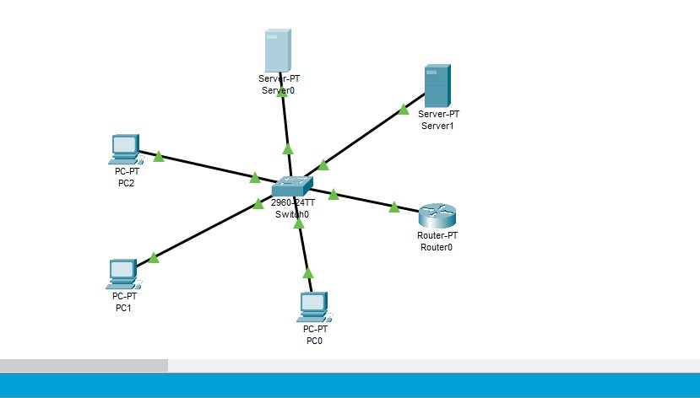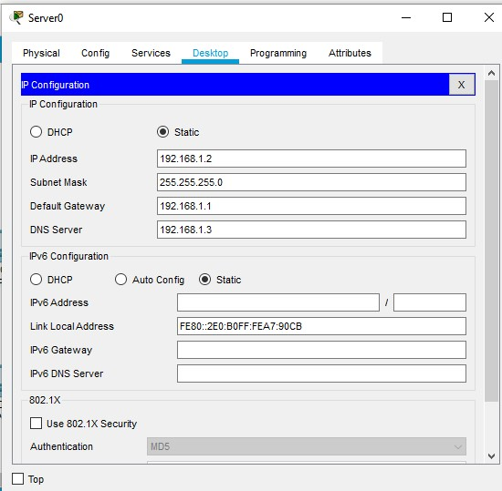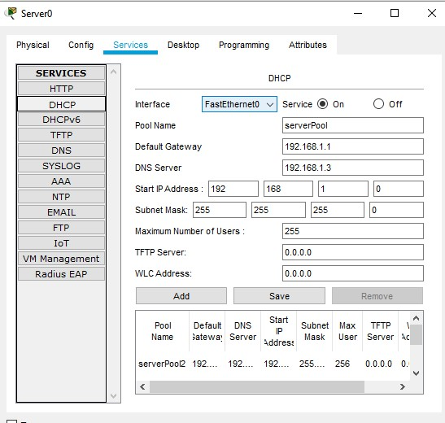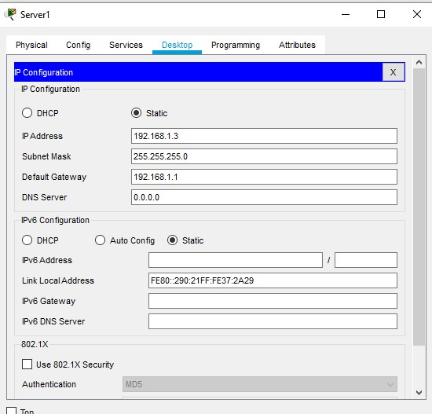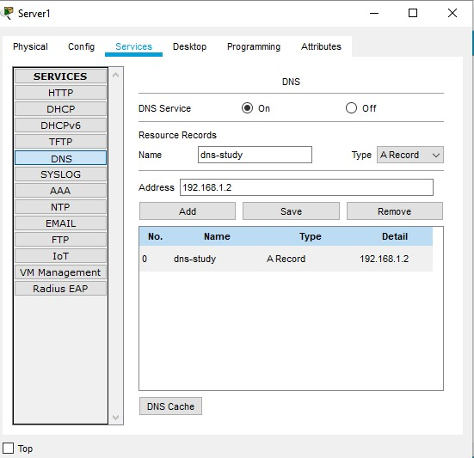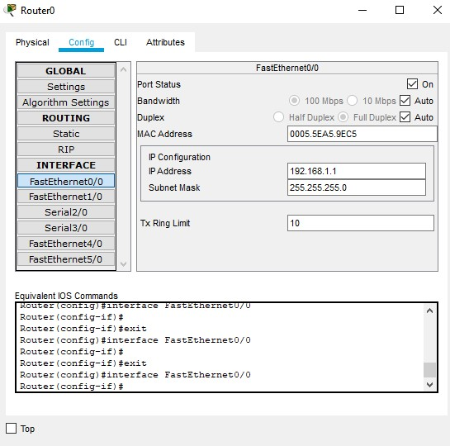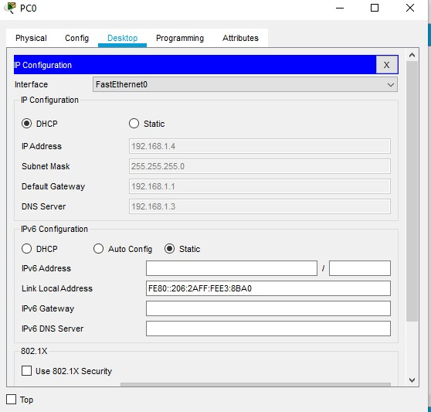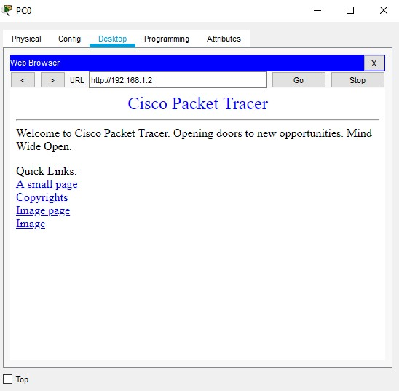

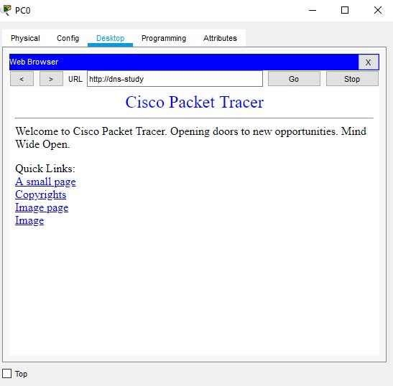

**CONCLUSION**

Thus we have studied how to configure a DNS server in cisco packet tracer. Domains can be accessed using their IP addresses.